

Food Donation System for Restaurants

**Student: Zorica Nikoloska**

**Professor: Aleksandar Karadimce**

**Table of Contents:**

**Introduction………………………………………………………………………………………1**

**Purpose…………………………………………………………………………………………….2**

**Scope………………………………………………………………………………………………..3**

**Product Perspective………………………………………………………………………….4**

**Product Functions……………………………………………………………………………..5**

**Stakeholders……………………………………………………………………………………..6**

**Possible User Demands……………………………………………………………………..7**

**Architectural design………………………………………………………………………….9**

**Functional Requirements…………………………………………………………………18**

**Non-Functional Requirements…………………………………………………………19**

**User Interface Design using Figma……………………..……………………………20**

**Login Activity Diagram…………………………………………………………………….21**

**Use Case Diagram…………..……………………………………………………………….24**

**Component Diagram……………………………………………………………………….25**

**Sequence Diagram…………………………………………………………………………..26**

**Basic Functionality Test…………………………………………………………………..27**

**User Interface Test………………………………………………………………………….28**

**Compatibility Test…………………………………………………………………………..29**

**Performance Test……………………………………………………………………………30**

**Security Test……………………………………………………………………………………31**

**Future Evolution and Maintenance………………………………………………….32**

**Conclusion………………………………………………………………………………………34**

**References……………………………………………………………………………………...35**

**Introduction**

The Food Donation App aims to connect restaurants with local charities, food banks, and individuals in need by facilitating the donation of surplus food. The app will simplify the donation process, ensuring that food is distributed efficiently and ethically, reducing food waste and benefiting the community.

This project represents a step toward addressing global food insecurity and environmental sustainability. By creating a digital platform, the app will bridge the gap between surplus food producers and those in need, streamlining the donation process and making it accessible to a broader audience. Additionally, the platform will incorporate features to ensure compliance with food safety standards and provide metrics to track the impact of the donations.

The system will be developed as mobile application, offering features such as donor registration, real-time donation tracking, recipient matching, and detailed reporting capabilities. The project’s goal is to foster collaboration between restaurants and charitable organizations, ensuring surplus food is put to good use while adhering to food safety standards and maintaining transparency in the donation process.

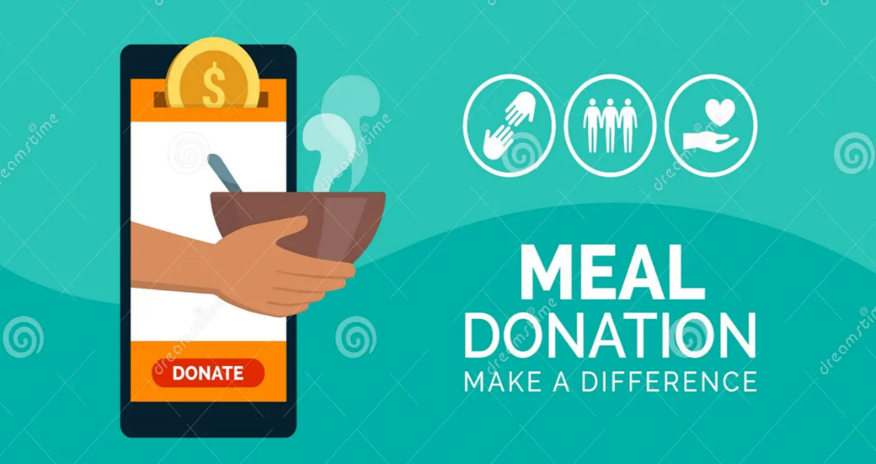

1

**Purpose**

The Food Donation System for restaurants is designed to streamline the process of donating surplus or excess food to charitable organizations, shelters, and individuals in need. The primary purpose of this system is to ensure that edible food, which would otherwise go to waste, can be redirected to help alleviate hunger in communities. By providing a user-friendly platform for restaurants to manage donations, it supports sustainability efforts, reduces food waste, and fosters corporate social responsibility.

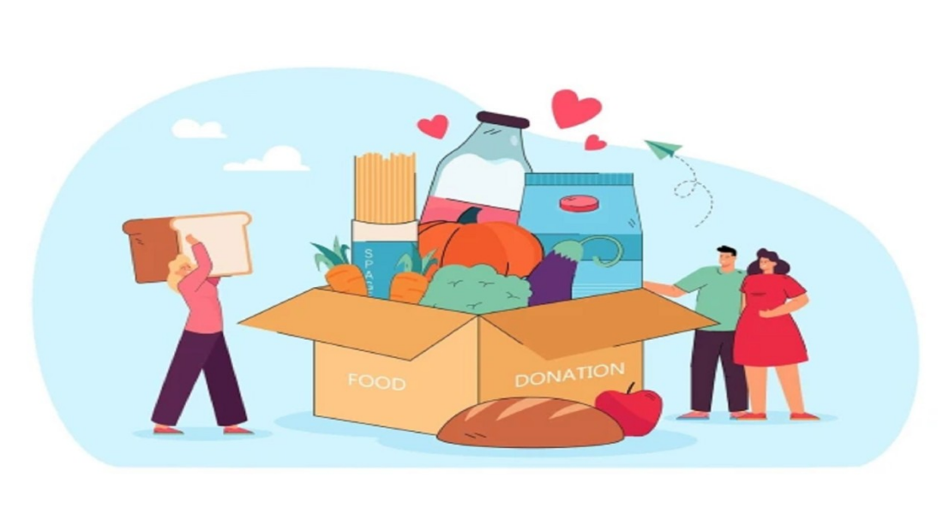

2

**Scope**

The system is intended for use by restaurants, food vendors, and catering services that regularly prepare and serve meals. It will help these establishments manage the donation of unsold or leftover food in a way that meets health and safety regulations. The scope of the system includes:

* Registration and management of restaurants and donation recipients (charities, shelters, etc.).
* Integration with restaurant inventory systems to track surplus food available for donation.
* Scheduling and organizing donation pickups.
* Ensuring compliance with local food safety and donation laws.
* Real-time tracking of donated items and receipts for restaurants for tax deduction purposes.
* Notification and reporting features for both restaurants and recipient organizations.
* This system can be implemented on a local or national scale, with the possibility of expanding features to accommodate different regions and larger networks of food donors and recipients.

3

**Product Perspective**

The Food Donation System is a mobile application accessible to restaurant owners, staff, and charitable organizations. It will be integrated with the restaurant’s point-of-sale and inventory systems, allowing easy tracking of unsold food items. The system will include user authentication features, real-time data reporting, and mobile notifications to ensure that both donors and recipients can coordinate donations effectively.

The platform will serve as an intermediary between food donors (restaurants) and recipients (charities), acting as a logistics tool to handle the operational aspects of food donation. The system will ensure that donations are made within the legal framework of food safety regulations, facilitating transparency and accountability.

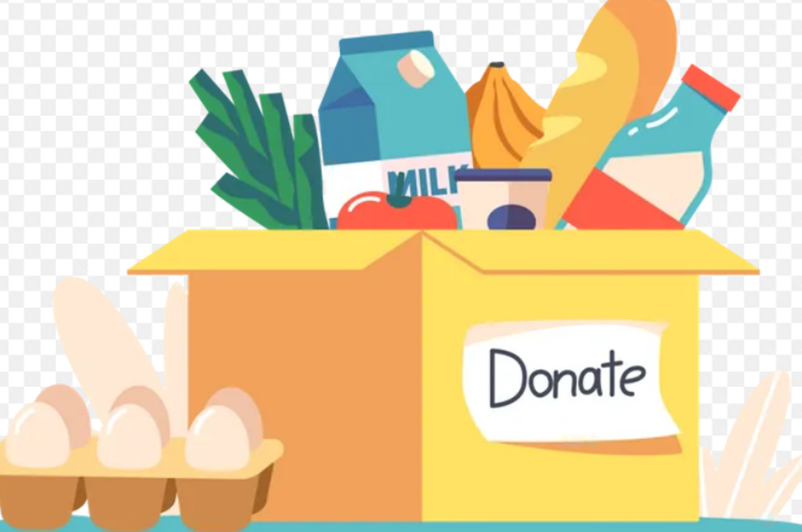

4

**Product Functions**

**Restaurant Registration and Profile Management:** Restaurants can register on the platform and create a profile, including location, types of food prepared, donation preferences, and available pickup times.

**Inventory Tracking:** Integration with the restaurant’s inventory system to track surplus food items that can be donated. Notifications when food items near expiration or become excess to help manage donations timely.

**Donation Scheduling and Coordination:** Ability to schedule donation pickups based on available times. Automated notifications to both the restaurant and the recipient organization about the pickup details.

**Recipient Registration:** Charitable organizations, shelters, and other food banks can register to receive food donations.

**Legal and Safety Compliance:** Information and guidance about food donation laws and safety regulations to ensure all donations meet the necessary guidelines.

**Reporting and Receipts:** Provide documentation of donations, including itemized lists and estimated values, for tax deduction purposes.

**User Dashboard:** Dashboard for restaurant staff and charity recipients to manage donations, view schedules, track items, and access reports.

**Data Analytics:** Analytics tools to track donation trends, food wastage, and the impact of donations, helping restaurants measure their contribution to the community.

**Mobile Notifications:** Real-time alerts to notify both restaurants and recipients about pickup schedules, changes, or any issues in the donation process.

5

**Stakeholders**

**This application is intended for:**

**Restaurants:** Primary donors who will use the app to list surplus food items, manage donations, track their contributions, and receive feedback.

**Charitable Organizations:** Recipients who claim or request food donations to serve their communities and maintain records of received items.

**Delivery Services:** Logistics partners responsible for picking up and delivering donations, often collaborating with both restaurants and charities.

**End Beneficiaries:** Individuals or groups receiving food donations indirectly through charitable organizations.

**System Administrators:** Managing and maintaining the application, ensuring smooth operations, monitoring usage trends, and resolving disputes.

**Developers:** Building, maintaining, and updating the system to meet evolving technical and user requirements.

**Sponsors or Funders:** Organizations or individuals providing financial support for development and operations, often requiring impact reports.

**Regulatory Bodies:** Ensuring the app complies with laws and standards related to food safety, environmental regulations, and data privacy.

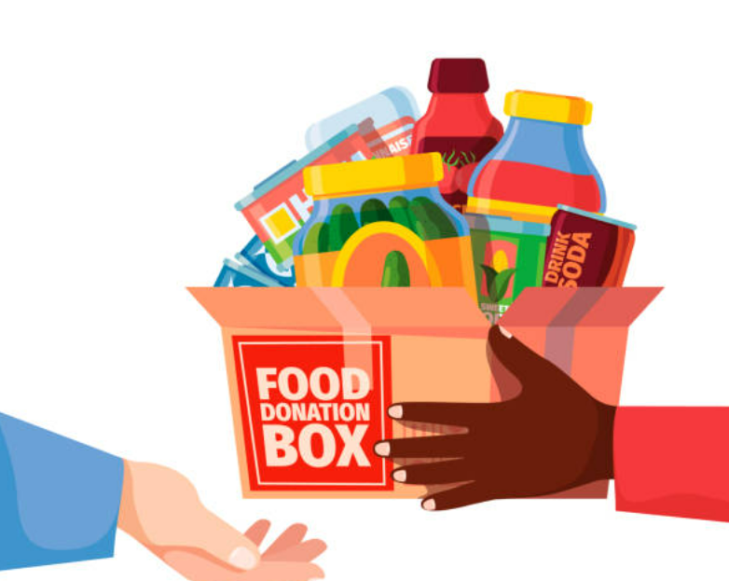

6

**Possible User Demands**

**Ease of Use:** Simple and intuitive navigation for all user types, including visually appealing and functional interfaces, with detailed help guides and tutorials.

**Food Listings:** Ability to upload detailed food information, including type, quantity, expiry date, packaging conditions, photos, and any special instructions.

**Real-time Matching:** Automated notifications for charities when new donations are available, with advanced filters for preferences, proximity, and dietary needs.

**Scheduling:** Flexible integration for scheduling pickups or deliveries, with options for recurring schedules or instant pickups for urgent donations.

**Food Safety Compliance:** Tools and guidelines to ensure donated food meets safety standards, with built-in reminders for expiring items and documentation of food-handling practices.

**Communication Tools:** Secure messaging between donors, charities, and logistics providers to coordinate pickups and resolve issues efficiently.

**Reporting and Analytics:** Advanced data on donation history, quantities donated, beneficiaries served, and environmental impact metrics such as reduced waste and carbon savings.

**Notifications:** Customizable alerts for new donations, confirmations, reminders, updates on delivery status, and urgent needs from charities.

**Multilingual Support:** Accommodating users from diverse linguistic backgrounds to broaden accessibility, including translation tools.

7

**System Architectural Design**

The system will be developed using 3-tier architecture:

Presentation Layer (UI): Presentation layer contains pages like windows form where data is presented to the user or input is taken from the user.

Business Access Layer (BAL) or Business Logic Layer: BAL contains business logic, validations or calculations related with the data, if needed.

Data Access Layer (DAL): DAL contains methods that helps business layer to connect the data and perform required action, might be returning data or manipulating data (insert, update, delete).

The three important modules like the UI, logic and database are independent of each other and are clearly defined. Also modifying any one tier will not affect the other.

Along with it we get the following benefits for using 3-tier architecture:

Scalability: Each tier can scale horizontally. For example, you can load-balance the Presentation tier among three servers to satisfy more Web requests without adding servers to the Application and Data tiers.

Performance: Because the Presentation tier can cache requests, network utilization is minimized, and the load is reduced on the Application and Data tiers. If needed, you can load-balance any tier.

Availability: If the Application tier server is down and caching is sufficient, the Presentation tier can process Web requests using the cache.

9

**Proposed Methodology**

Proposed methodology can be classified into two parts client side and another is server side methodology.

*1) Client Side Methodology:*

Client side application workflow shown in fig.1. It divided into three parts.

Donor can firstly register on app then login it. After completion of login there are three option donate food, charity and about us. First phase are donate food select

the donate food option enter the whole information like food type, food quantity, latitude and longitude value, donor name and contact number. Data are saved on to the web server application then charity checks for the verification.

After find the food deliver to the hungry people.

Secondly click on charity it shows the list of charity and mapped

charity on Google map select the nearest charity from donor

location. Last is about us can provide the information about

the application.

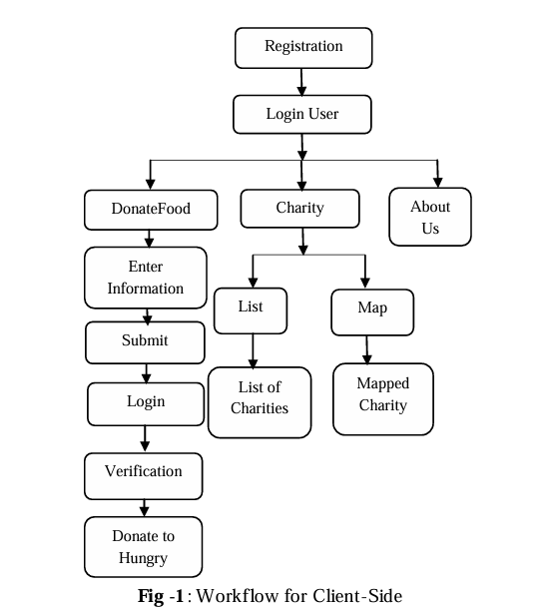

10

*2) Server Side Methodology:*

Server side application workflow shown in fig.2.

On server side it stored the list of donor by date wise so we can easily

analysis which type of food is more wastage and from where so it is beneficial for the future requirement.

Secondly it is more important to shows the optimal distance between donor to charity and donor to needy.

Charity can contact to the donor and needy resp. and take responsibility for

transportation and deliver to needy securely.

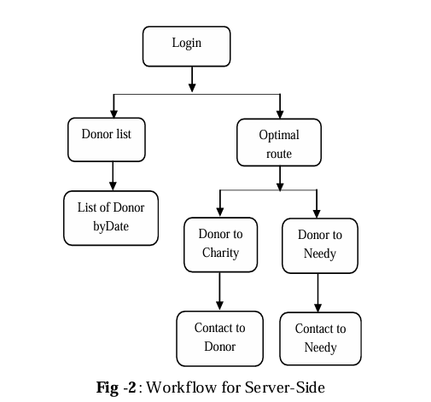

11

*3.2 System Overview*

The system architecture is divided into 3 parts, the development of the client side which is cross- platform. Smartphone app which consist of by food donation part.

Firstly they register and provide the information and submit. The Google web services used for getting the nearby search charities from the current location of donor in Smartphone app which provide mapping of the nearby charities on to the

Google mobile maps along with fetching required information that user wants at the time of donate food such as geo-location of place, mapping facility to see on to the Google maps. Different technologies used to make waste food application, those are JQuery, PhoneGap (Apache Cordova), Html 5, JavaScript, CSS for the development of the client side waste food supply chain App.

Html5 provide great platform to developed cross- platform mobile applications by using PhoneGap technology. All platforms support Html5 so that we can make web

application as a mobile one. AJAX is used to connect client and server for storing database waste food supply chain using MYSQL server on server side along database with server scripting PHP. The haversine equation is used to compute the distance between donors to charities and donors to needy geo-location by using geo-coded address form donor search current address and provide all services under required distance. Integrated steps involved to design the system are as follows.

*1) Smartphone User Interface:*

Waste application consists of cross-platform PhoneGap app

which can run in all major operating system such as Android, iPhone, Windows.

App consist of providing supply chain facility such as quantity of waste food. Web based services allowing quantity of waste food to be donated from the donor location (eg. Hotel, restaurant, wedding halls etc.) to charities.

Location based services search nearest charities from the donor’s location.

Then Charities can easily find, secure and deliver food to those who need it.

12

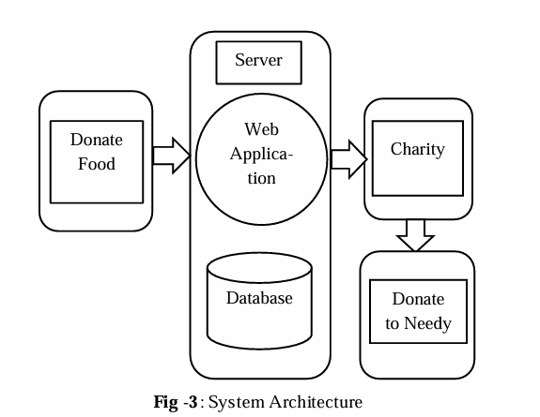

*2) Configuration of Map on Device using Google Web*

Services: To use nearest location Google facility on to the Smartphone, we register onto the Google console, which provide different web services such as for used Google maps on to the mobile we need to generate server-key from console and used onto the device. To display maps onto the device we need to use Google maps followed by key and type of quantity of food charity wants too used.

*3) Build Web Server:*

The PHP and MYSQL are used to design the web application server which is used to display all the donor information are registered and submit to the charity. Web

mapping Facility (WMS) is used to point all charities from the Google maps web services and GIS location based services are for displaying addresses from client position onto the maps.

13

*4) Build Client-Server Intermediate:*

JSON (JavaScript Object notation) is an insubstantial data exchange format along with AJAX request helps to make web service connection in between client and server. After the requirement is completed, the charity volunteer

have been visited in place of donor person and deliver food

to needy.

*3.3 Technologies Used*

It is important to remember that some technologies are present

only in the client (PhoneGap, SQLite, JQueryMobile), some only in the server

(PHP,MYSQL) and some are found on both (JSON).

*Front-end Interface will handle:*

* Restaurant Users: Upload surplus food details, schedule pickups, track donation status, view impact metrics, and manage profiles.
* Charities: Search donations, communicate with donors, provide feedback, and request specific types of food when needed.
* Admins: Monitor and manage donations, users, and system data, resolve disputes, and generate system-wide performance insights.

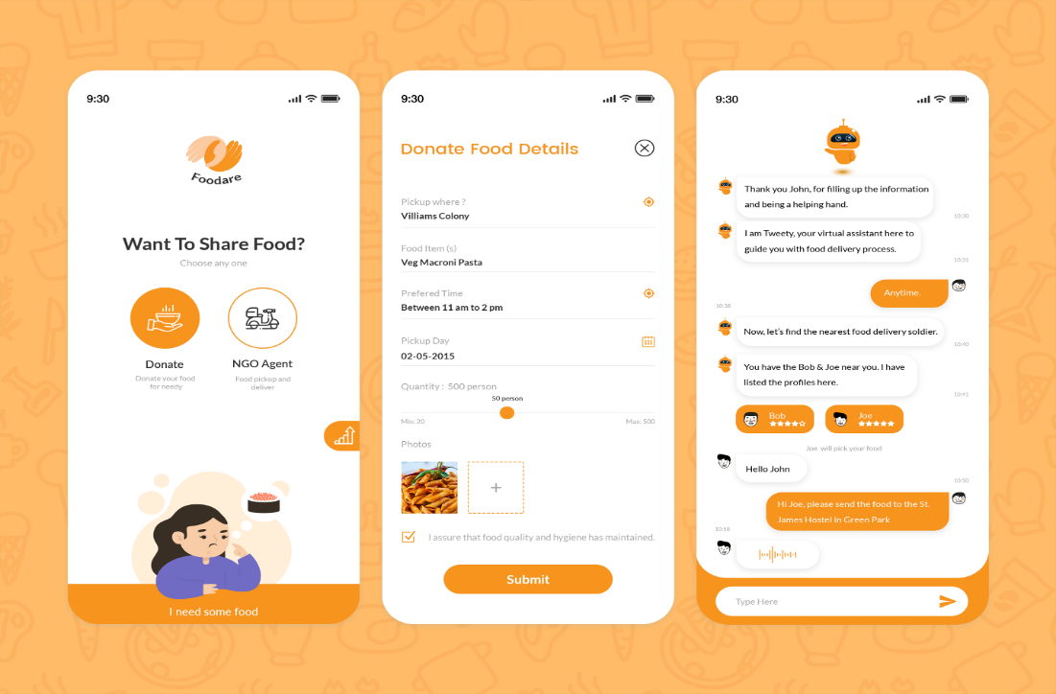

14

*Features include:*

* Intuitive dashboards tailored for each stakeholder group.
* Advanced search and filtering capabilities for food items, including geolocation-based searches.
* Interactive calendar for scheduling pickups/deliveries with color-coded status indicators.
* Responsive design ensuring usability on various screen sizes, devices, and operating systems.
* Multilingual support for enhanced accessibility, with dynamically adjustable interface languages.
* Integrated tutorials and help sections to guide first-time users

*Back-end Server*

The server will handle:

* Secure storage and management of donation, user, and transaction data.
* Communication between the front end and the database, including API integrations for logistics and payment gateways.
* Automated workflows for donation matching, notifications, and real-time status updates.
* Logging and monitoring tools to track application performance and detect anomalies.

15

*Database*

The database will store:

**User Information:** Comprehensive registration data for restaurants, charities, and admins, including user roles, preferences, and activity logs.

**Donation Details:** Extensive data on food type, quantity, expiry, packaging, photos, and pickup schedules.

**Transaction History:** Detailed logs of completed donations, including timestamps, recipients, and delivery outcomes.

**Feedback Records:** Ratings, comments, testimonials, and issue resolution logs to enhance trust and service quality.

**Impact Metrics:** Data on environmental savings, quantities donated, and lives impacted for reporting purposes.

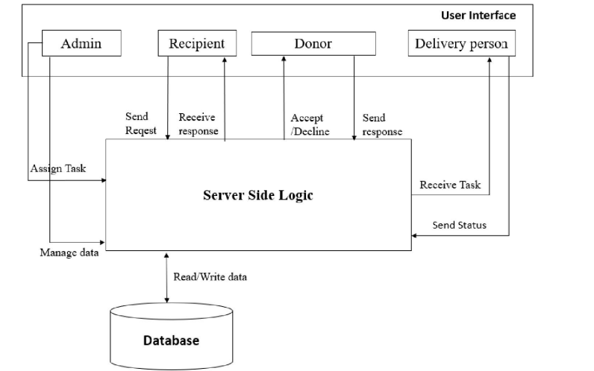

16

The Entity Relationship (ER) Diagram:

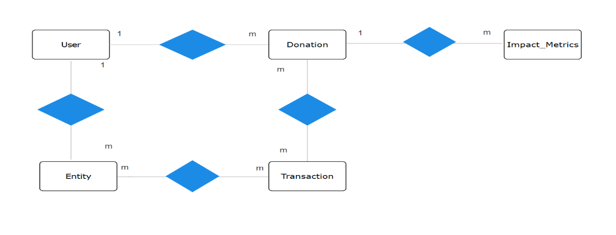

17

**Functional requirements**

*These are the requirements that the end user specifically demands as basic facilities that the system should offer.*

1. *For donor:*

*Donate item*

*Check where the volunteer has reached and the status of the donated item*

1. *For volunteers:*

*Accept the request given by the management*

*Go to the locations and pick up the items that are provided by the donor*

1. *For the management:*

*Accept and manage requests by the donors and assign volunteers*

*Keep track of the performance of the volunteers*

1. *For admins:*

*Admins shall manage the database information and shall do relevant tasks related to the same.*

18

**Non-functional requirements**

*They are basically the quality constraints that the system must satisfy, which are also called non-behavioral requirements.*

1. *Portability: It should be available for the majority of users.*
2. *Usability: The system needs to be easy to use and understand.*
3. *Privacy: The application shall take care of not to leak any donor’s personal profile information to other users or people. Only the information relevant and necessary should be visible.*
4. *Performance: The application should respond to users in a considerable time window. It should not be too slow or too fast for the users. The application’s response should not hinder the user in his/her tasks.*
5. *Scalability: The application should be able to adapt to itself to the increased user load to handle more data as time progresses.*
6. *Reliability: The application should be reliable to perform its tasks. For example: A user should rely that in case he wishes to donate, the request is sent to the volunteer side otherwise it would be an unreliable app.*

19

*User Interface Design made using* ***Figma****:*

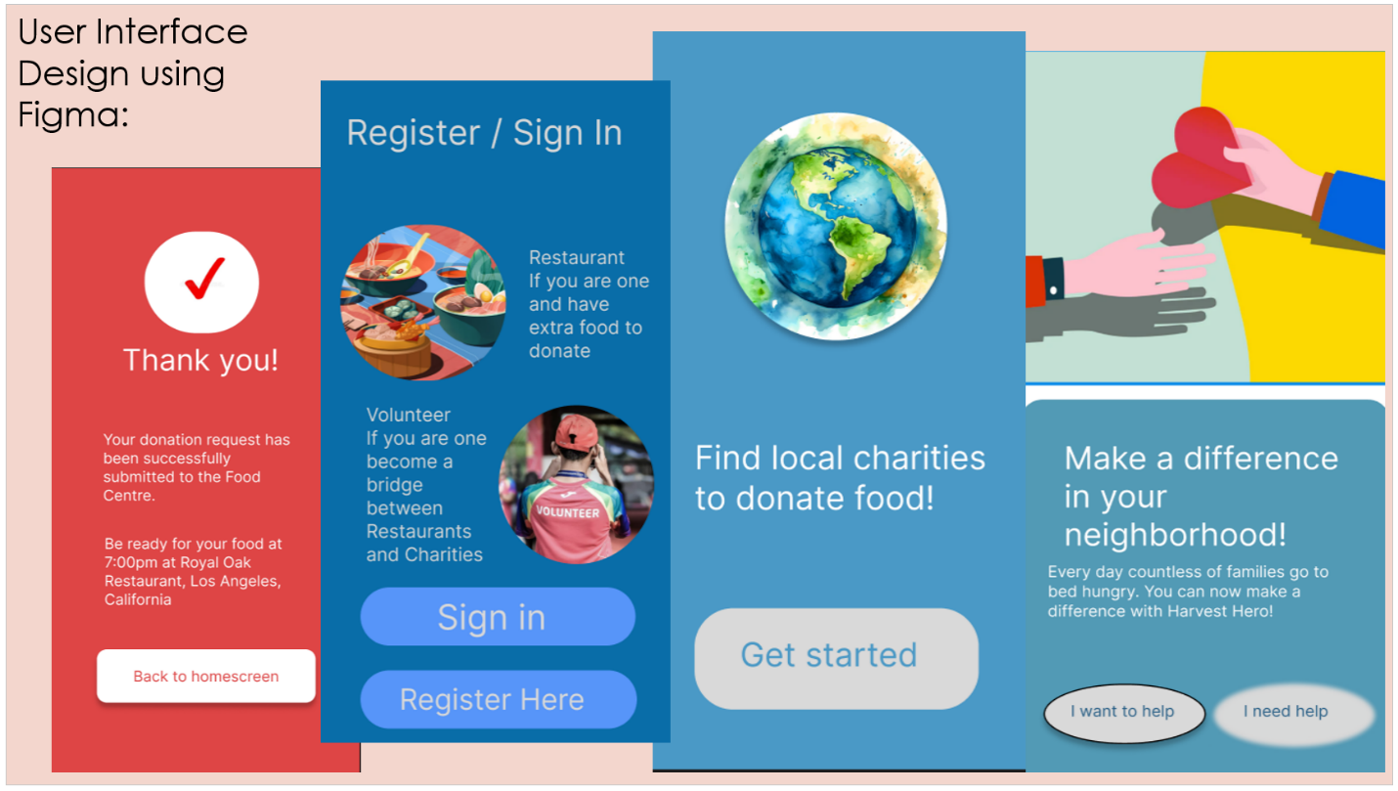

**Some of the elements:** Restaurant Dashboard: For posting food donations, tracking donations, managing profiles, and accessing donation reports, Recipient Dashboard: For browsing available donations, confirming donations, and managing pick-up schedules, Admin Dashboard: For overseeing the app's operations, managing users, and generating reports, Welcome Screen representing the logo and a headline example: Make a Difference Today!, Buttons for (Donate Now, Get Started, Back to home screen, Sign in, Register), Showing the main donation screen as well donation confirmation, donation history screen.

20

1. **Login Activity Diagram:** starts when the user enters their username and password. The system then checks if the credentials are correct, if they are incorrect, an error message will be shown, and the user can either retry the login or reset their password. The password reset option leads the user to a screen where they can enter their email for a reset link.

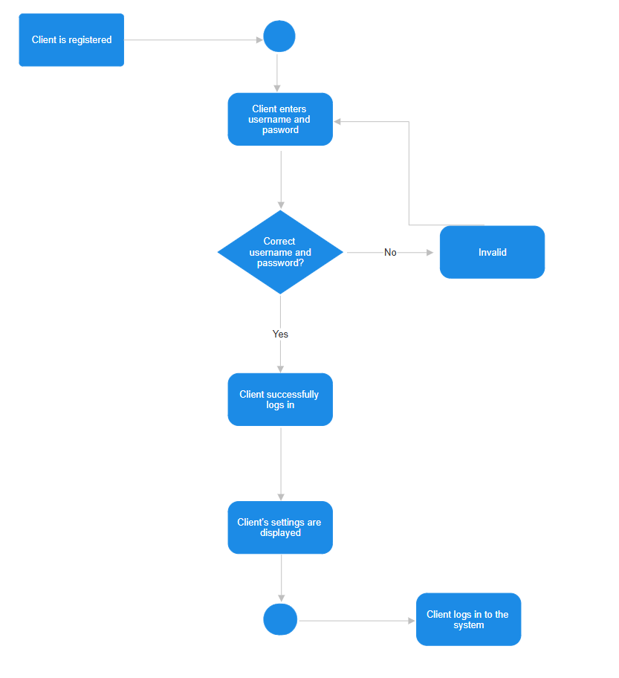

21

**Algorithm:**

1. **Start the application.**
2. **Register by filling the necessary details.**
3. **Select the option of donor or volunteer accordingly.**
4. **If you wish to donate, go to the donation page by clicking on Donor button.**
5. **Click on create donation.**
6. **Fill up the details and click Submit.**
7. **If you wish to see donation request, click on Request for Food option.**
8. **If you are in need of food go to the request food option, which is on the volunteer page.**
9. **Fill up your requirement and click on Request button.**
10. **If you wish to see the available food listed by donors click on Available food button.**

22

**If the user is a donor:**

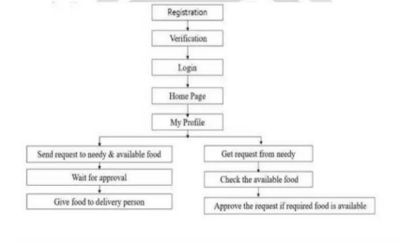

**If the user is a volunteer:**

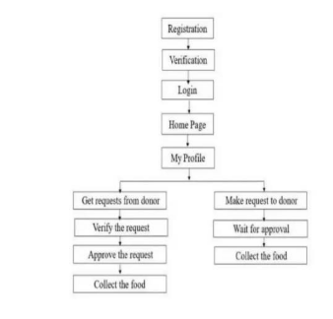

23

1. **Use Case Diagram:** describes the functional requirements of the system and show how different types of users interact with the system.

Actors:

1. Customer: The user making donations.
2. Restaurant Admin: The restaurant management who oversees donations, goals, and financials.
3. Payment Gateway: External system to handle payments.

Use Cases:

* Customer: Browse restaurant information, Make a donation, View donation history, Set up recurring donations, Share donation on social media.
* Restaurant Admin: Manage donation goals, View donation statistics, Set up donation campaigns, Manage donation reports.
* Payment Gateway: Process donation payments and Verify transaction details.

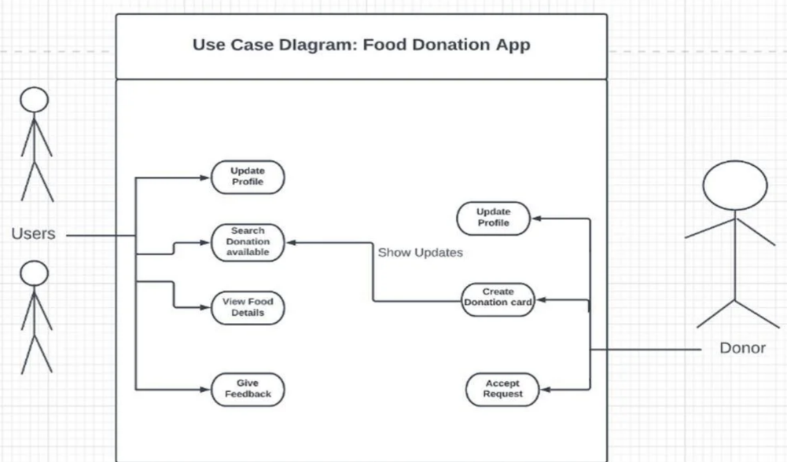

24

1. **Component Diagram:** breaks the system into smaller components or subsystems that interact with each other.

Components:

* User Interface (UI): Displays the app interface and user interaction flow (donation form).
* Donation Management: Manages donations, including amount, frequency, and history.
* Payment Processing: External component (PayPal) to handle financial transactions.
* Notification Service: Sends push notifications, emails, and updates to the user.
* Reporting & Analytics: Generates donation statistics, progress toward goals, and donation reports for admins.
* Database: Stores user information, donation records, and transaction logs.

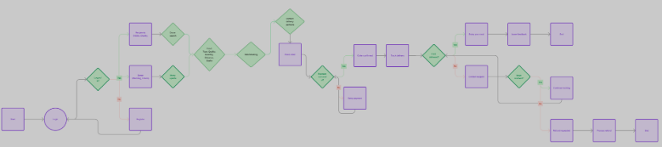

25

1. **Sequence Diagram:** shows how objects interact with each other in specific time sequence.

Tasks:

1. The user opens the app and selects a donation amount.
2. The App validates input and checks user profile.
3. The App contacts the Payment Gateway to initiate the payment process.
4. Payment Gateway processes the payment and returns the transaction result.
5. The App displays a confirmation to the customer with a receipt.
6. The App updates the donation history and sends confirmation to the restaurant.
7. The customer can opt to share the donation or continue browsing.

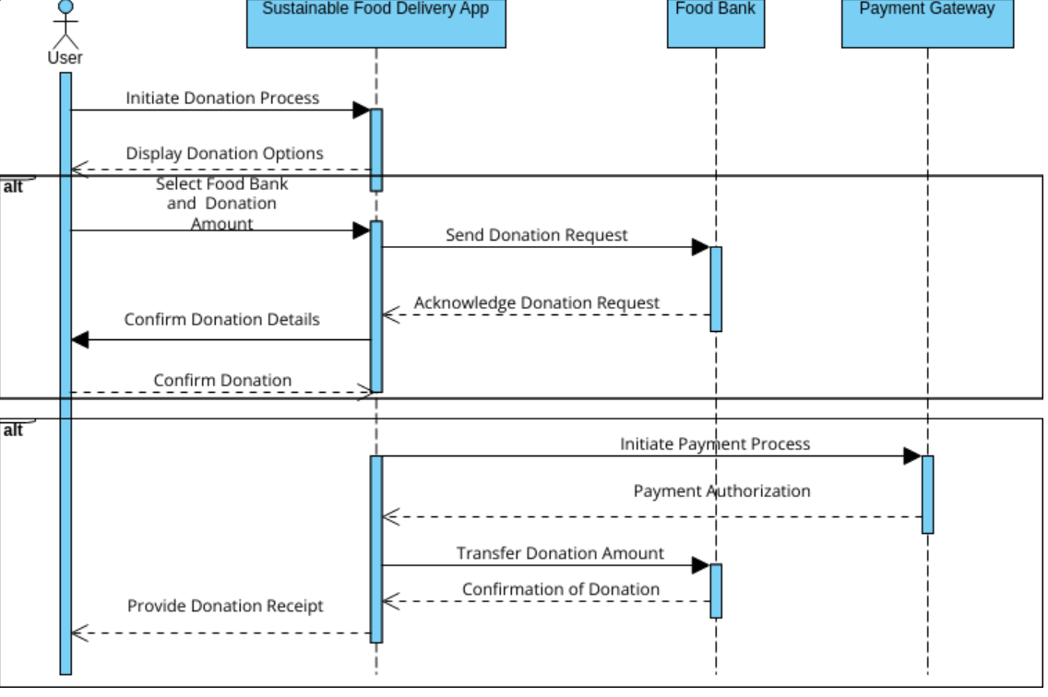

26

**Design tests**

1. **Basic functionality:** Ensures that the core features of the app works

as intended. Such as: verifying that the donation processing, user registration, donation history and the others work without errors.

The next thing is implementing data input validation that tests valid or invalid inputs about donation amount or payment details. As well as ensuring that the user can complete a basic task and that is making a donation step by step from start to finish.

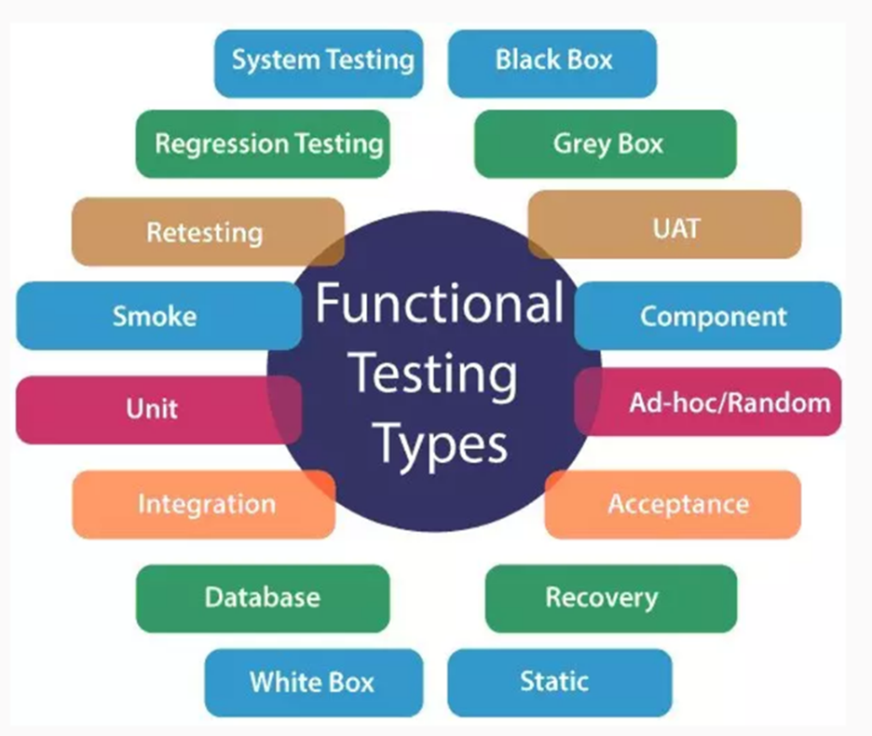

27

2. **User Interface**: With this kind of test we can be ensured that the visual elements of the application are responsive, accurate, consistent. This test also checks the navigation, whether users can easily navigate through different screens or moving from page to page.



28

3. **Compatibility:** One of the most important concerns is whether the app is compatible with different devices, browsers, operating systems in different network environment ensuring that the experience that the user will be easily accessed.



29

4. **Performance:** Evaluates how the application behaves under various load conditions such: checking the speed, responsiveness, stability of the system, as well as handling normal or complex user traffic. The stress testing is also important because it will provide us details of how the application behaves under extreme conditions to determine things such: very large number of users or data requests and determining the scalability of the app, as the users are increasing over time. The response time is also tested, providing details of how long it takes for the application to respond to some of the user actions such as: making a donation or loading pages, the throughput is measured as well, providing information of data that the system can handle at a time.

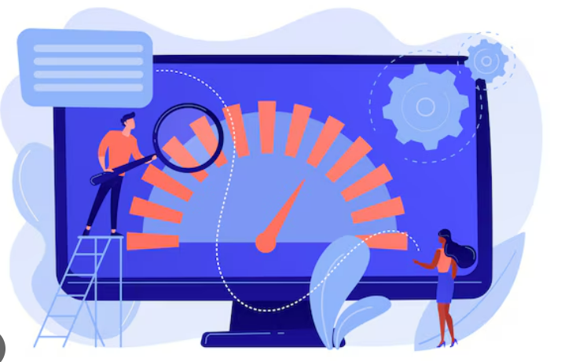

30

1. **Security:** Ensures that the application is well protected from various vulnerabilities, ensuring that the user data and transactions are kept safe. This means checking whether the users are properly authenticated and authorized, determining if the sensitive data is encrypted during the transmission with HTTPS request, the input validation is also checked, by implementing SQL injection and cross-site scripting. Session management is a test that checks whether the sessions that occur are properly managed.

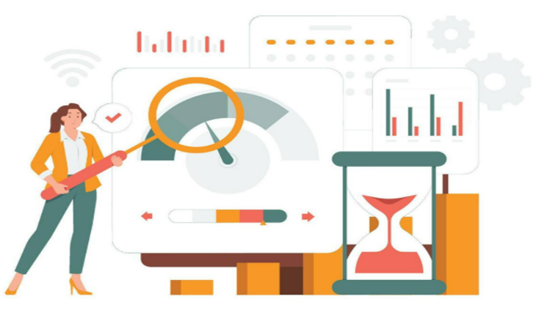

31

**Future Evolution and Maintenance**

The future evolution and maintenance of a food donation application for restaurants will be an intricate process, driven by the need to address food insecurity, minimize waste, and build a sustainable ecosystem. The application’s growth will likely focus on leveraging advanced technologies such as AI, machine learning, and IoT to improve every aspect of its functionality. For instance, AI algorithms can predict surplus food quantities based on real-time data from restaurant inventory systems, customer trends, and seasonal patterns, while machine learning can optimize matching processes to pair donations with the most suitable recipients based on location, urgency, and dietary requirements. IoT integration, such as smart inventory sensors, could provide restaurants with automated alerts to donate food nearing its expiration, reducing waste before it occurs.

Maintenance will involve periodic updates to enhance user experience, ensuring compatibility with new devices and operating systems while incorporating multilingual and accessible design to reach a global audience.

The app’s evolution will also include expanding its stakeholder network to include not just restaurants but grocery stores, event organizers, catering companies, and even individual households.

By developing APIs for seamless integration with third-party platforms like point-of-sale systems, logistics providers, and delivery apps, the application can create an interconnected ecosystem that simplifies donation processes. A cloud-based infrastructure will support scalability, handling increased user traffic and enabling efficient data sharing across geographies. Furthermore, blockchain technology could enhance transparency and trust by providing a secure, immutable record of food donations, ensuring accountability and encouraging greater participation.

32

From a community perspective, fostering engagement through social features, such as impact dashboards, storytelling, and gamification, will play a pivotal role in sustaining interest. Donors could track metrics like the number of meals they’ve contributed or the carbon footprint reduced through their actions, creating a sense of accomplishment. Regular campaigns, partnerships with influencers, and educational initiatives on food waste and hunger could amplify the app’s reach. Security will remain a top priority, with strong encryption, GDPR compliance, and regular audits to safeguard user and organizational data.

To align with global sustainability goals, the app could integrate features to quantify and report its broader environmental impact, such as water and energy savings from avoided waste. Collaboration with Non- Governmental Organizations, government bodies, and corporate sponsors could provide funding and policy support, enabling the app to operate in underserved or rural areas where food insecurity is most critical.

Over time, the app could evolve into a comprehensive platform not only for food donations but also for broader sustainability efforts, such as recycling initiatives, meal-planning tools to minimize overproduction, and educational resources for responsible consumption. By combining cutting-edge technology with a deep commitment to social impact, the app has the potential to redefine how communities address hunger and waste in a more interconnected, sustainable future.

33

**Conclusion: A Game-Changer for Social Good**

Mobile applications have become an integral part of people's lives, serving various purposes, and their popularity continues to soar. The application aims to tackle food wastage by redirecting excess food to those in need, rather than it being discarded as trash. It provides users with information about the locations where surplus food is available, along with details about the quantity of food on offer. With its user-friendly interface, the application ensures ease of use for everyone.

Food waste is one of the issues currently facing the planet as a whole. Necessary steps should be taken to stop food waste, otherwise the people of the world will suffer from food scarcity. If you can save food from being wasted, with the goal of feeding the hungry people who has no food to eat. The main goal is that the food wastage will be reduced and to establish a link between restaurants or individual users who has food surplus and charity organizations who has volunteered to collect the excess food.

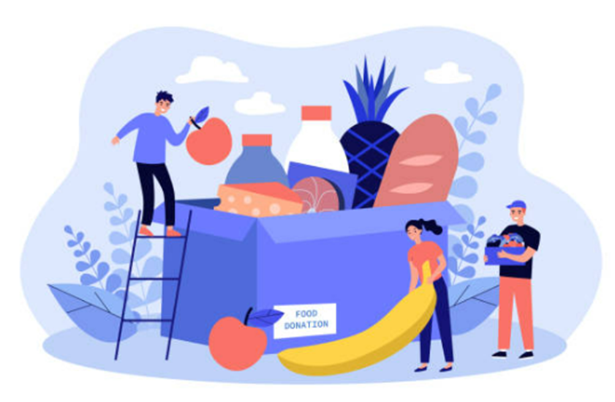

34

**References:**

<https://www.smartdraw.com/>

<https://www.figma.com/>

<https://lovefoodnotwaste.org/>

<https://www.apple.com/home-app/>

<https://www.ijarsct.co.in/A17803.pdf>

https://ieeexplore.ieee.org/document/8488190

https://www.ijiemr.org/public/uploads/paper/998371652363273.pdf

https://chatgpt.com/

https://ijarsct.co.in/Paper17803.pdf

https://www.slideshare.net/slideshow/food-donation-project-report-ii/249974874

35